FEAR is in control of part of your life.
FEAR Be Gone
Part 3, Techniques to Unlearn Fear

I have had many clients tell me that when they first walked into my office, they had feelings of fear and anxiety. But later, when they came for their appointment, there was a feeling of anticipation and peace. So, what changed? Doing something new for the first time, no matter if it is going to a new doctor or learning to ride your first bike or getting up in front of a group of a hundred people and talking, can create feelings of fear and anxiety. This can also be one of the easiest fears to overcome.
You get through fear
by doing what you are afraid to do.

Cognitive Therapy is an approach that works well when there was no traumatic event connected with your fear. Test anxiety is an example of a fear that can be dealt with in this logical manner. Here, you ask yourself a series of questions that can help you with any anxiety in the left side of your brain. Identify the fear and then start with the catastrophic thoughts that flood your mind:
- What is the worst thing that could happen if I freeze up on the test? (Catastrophic)
- How likely is it to happen? (I have a 60% chance of freezing up.)
- If the worst happened, could I live through it?
- What are my options if the worst happens?
- What is the best that could happen? (Anastrophic)
- How likely is it to happen? (I have a 30% chance to ace the test.)
- If the best happened, could I live through it?
- What are my options if the best happens?

For some people, the anastrophic is worse than the catastrophic. “If I aced the test, then I would graduate and have to go out into the real world and get a job.” Going through these questions can lead to the discovery of more fears. “What happens if I can’t find a job, or I find a job and cannot do it and get fired.” Can you remember your first day at kindergarten when your mother walked out and left you with this strange person and a bunch of strange kids? How about your first day at your first job? This is all part of the fear of the unknown. Once you know what is going to happen and that you will survive it, you no longer experience the fear.

For each of these fears, you go through the same set of questions. The fears that are best resolved through this left-brain process are those without trauma connected to them.

Behavioral Therapy can help you overcome fears that you were born with. Airplane pilots have learned, during their parachute training, that the first time they jump will probably be sheer terror. The second time they jump, they will probably have high anxiety, but the sheer terror will be missing. The more jumps, the less anxiety they will experience. Yes, the fear of falling is one of the two fears that you were born with. The rule is still: You get through fear by doing what you are afraid to do. If you keep doing what you are afraid to do, you can reach a place where you will not experience any fear or anxiety.

There is a way to sabotage this type of behavioral therapy. After going safely through the fearful experience, you can say to yourself, “Boy, I guess I was lucky that time.” What that translates to is: it was not the skill of the pilot, or the engineers that built the plane. It was just luck and next time it could kill me. So the next time, you discover that the anxiety is still there.

Many of your behaviors may have underlying fears that keep them alive. Do you know anyone who will not say anything when they are used or are being taken advantage of? What is the fear that keeps some people from both setting and enforcing personal boundaries? Is it their fear of rejection? What is the fear that keeps some parents from setting and enforcing boundaries with their children? Is it their need to have their children love them? In cases like these, giving behavioral answers does little or no good. Usually, what you get back is a lot of: “Yes, buts,” and “I’ve already tried that.” The problem is not knowing what to do, it is dealing with the fears and beliefs that create these victim behaviors.

CREATING FEARS, PHOBIAS AND ANXIETIES
We do not react to People, Events, or Words. It is the meaning that you put to these events in your life that create fear. Something happens, and you put meaning(s) to what happened or to what is said. Depending on the meaning(s) you put to the event, you then experience feeling(s). You choose between the feelings that you are aware of and then select a behavior.

A few years ago, I had a client who had been raped about eight weeks before seeing me. She told me that one Saturday, she was sitting in her car at a stop sign when two guys jumped her and took her to a secluded spot. She had been working in her garden and did not smell or look attractive. After returning to her job, she was still feeling guilt and shame from being raped. She ended up starting fights with other employees and getting fired. When she came to see me, she said that she still felt guilty, dirty and ashamed. She said she was now starting fights with her husband. “I do not know what is the matter with me. I’m destroying all the things I love.”

We started looking at her feelings. After several weeks of struggling to discover what her underlying beliefs were that were creating the feelings, she said. “I know I’m not guilty, dirty or soiled. I wore nothing seductive and I did not know the two guys who raped me. I know I was in the wrong place at the wrong time, but I still feel the same.” What she discovered was that she had a core belief that “You should never have sex with someone you don’t love or care about! And that is where my feelings are coming from!” Once in she was able to identify this basic core belief, she could use her logic to change her feelings.

This process looks something like the following:

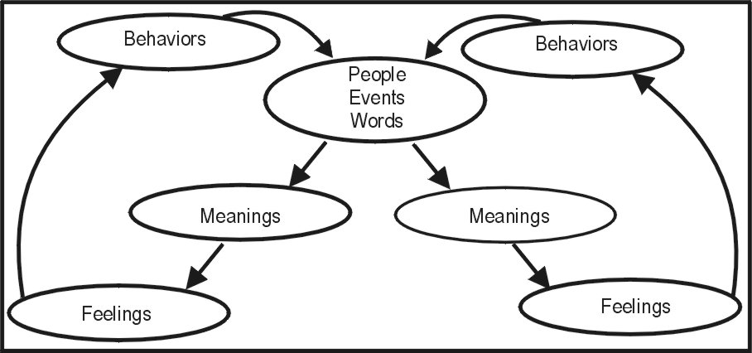

Something happens and you cannot change what has happened to you (people, events, words). But, what has happened to you will either be stored in the left side of your brain as a memory without emotion, or in the right side of your brain as an emotionally charged picture. Or, it can be stored in both with contradictory meanings. It is important to accept that you are the one, consciously or unconsciously, who is putting the meanings to the people, events and words. If you are the one who is doing this, then you can put different meanings to the same events and words. Not only can you change what things mean to you, but by doing that, you are also changing your feelings and your behavior!

Notice how the arrows in the diagram circle back around to people, events, and words. Once you have decided what something means, “She does not like me,” you now start looking for more evidence to reinforce your beliefs about what happened. The more evidence that you collect, the more generalized your belief becomes. Then, it can become “Women do not like me.”

There are three ways to change your feelings. All therapeutic approaches will use one or a combination of these three ways to help you change. There is the cognitive, logical, rational approach. “The way you are acting is illogical, therefore the rational thing would be to change your behavior.” A variation of that is “What did your mother do to you that made you this way?” The hypothesis is that if you can understand what happened to you, then you will be able to change your behaviors.

Up to now, we have been looking at cognitive ways of changing what things mean to you thereby changing your feelings. And, at how changing your feelings, changes your behavior. What is left now is to start looking at how to change your feelings directly.

The next method is used by behavioral therapist who will give you therapeutic behavioral interventions to hopefully change your feelings. A Freudian analyst will use basically a cognitive approach, while Albert Ellis will use a Cognitive-Behavioral therapy approach, CBT, to hopefully effect change in your feelings.

If your fear is in the left brain (cognitive issue) then that is where a therapist might start. The therapist might add some behavioral homework, such as making a list of your fears and then ranking them from 1 to 10 with 10 being the scariest of your fears. Then, in a step-by-step process, the therapist would have you do the least fearful of your behaviors, number 1, until you are no longer feeling any fear. Then, he would have you focus on number 2, and gradually work up your list to the most fearful behavior. It would probably take several months to get through your list. If a behavioral approach did not work with you, then your therapist might add some of Albert Ellis’s Cognitive-Behavioral interventions, CBT. Below is a third approach.

There is one more area, Feelings. The goal of both cognitive and behavioral therapy is to change the feelings. When the thinking (cognitive) changes, there is change in the behavior, but unless there is a permanent change in the feelings, there will be no permanent change in the individual. Look at the equilateral triangle below:

HOW TO EFFECT CHANGE IN FEELINGS USING ALL THREE SIDES.

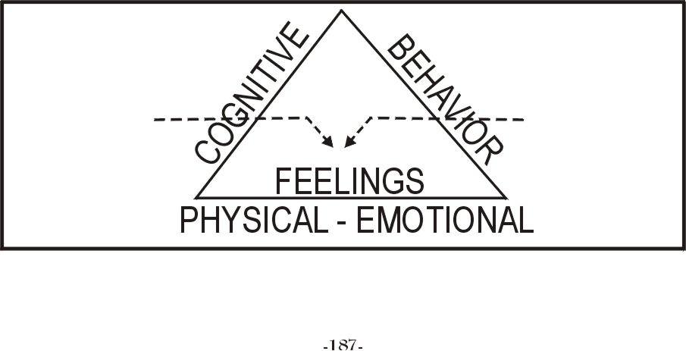
I prefer an approach that incorporates all three sides, CABT, Cognitive, Affective, Behavioral, in overcoming fear. The purpose of working with the Cognitive, Affective and Behavioral is to give the therapist the best chance to help you change your feelings. Not all therapists have been trained to use a CABT approach.
A therapist can use a strict Cognitive approach or a Cognitive-Behavioral approach to help you change your feelings. But, unless there is a permanent change in your feelings, there will not be a permanent change in your behavior. Because all behavior, conscious or unconscious, is based on your feelings.
Before every behavior is a feeling
That feeling may be coming from a cognitive belief system, or it may be coming from a picture in the right side of your brain. I have talked about several cognitive-behavioral techniques to change your feelings. The question now is, how do you change a picture that is stored in the right side of your brain? You cannot change a picture just by thinking it gone, nor by ignoring it or pretending that it does not exist.
Using right brain therapy techniques,
You can change your feelings directly.

In the next blog I will show you a right brain technique for changing a person’s fears and anxieties that I and Matt Perelstein have been using for over 30 years.

Myron Doc Downing PhD
email: docdowning103@Gmail.com
website: www.DocDPhD.com

